**Student Academic Record Management System**

**Ayush Mehta**

**School Record Management System is the project in which tried to make an app which is alone fully capable of and managing the Records of students from class 1-10. I got my for this projec from my school.**

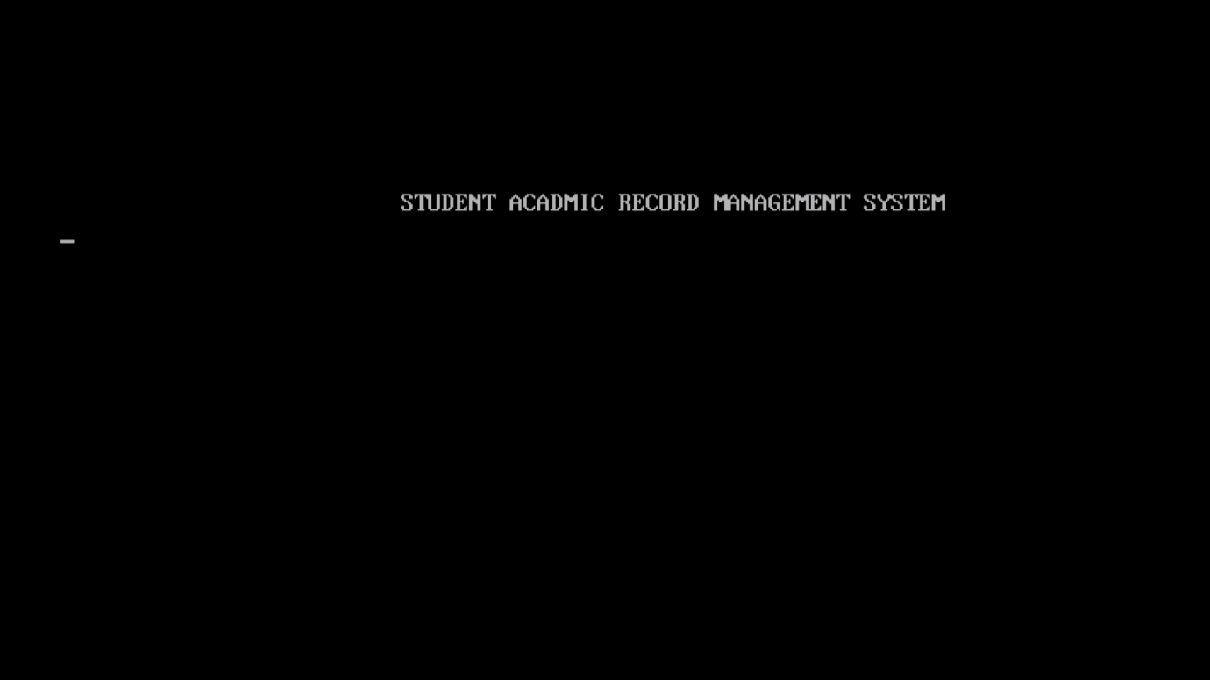

**MENU**

**To navigate just press the corresponding key to the option.**

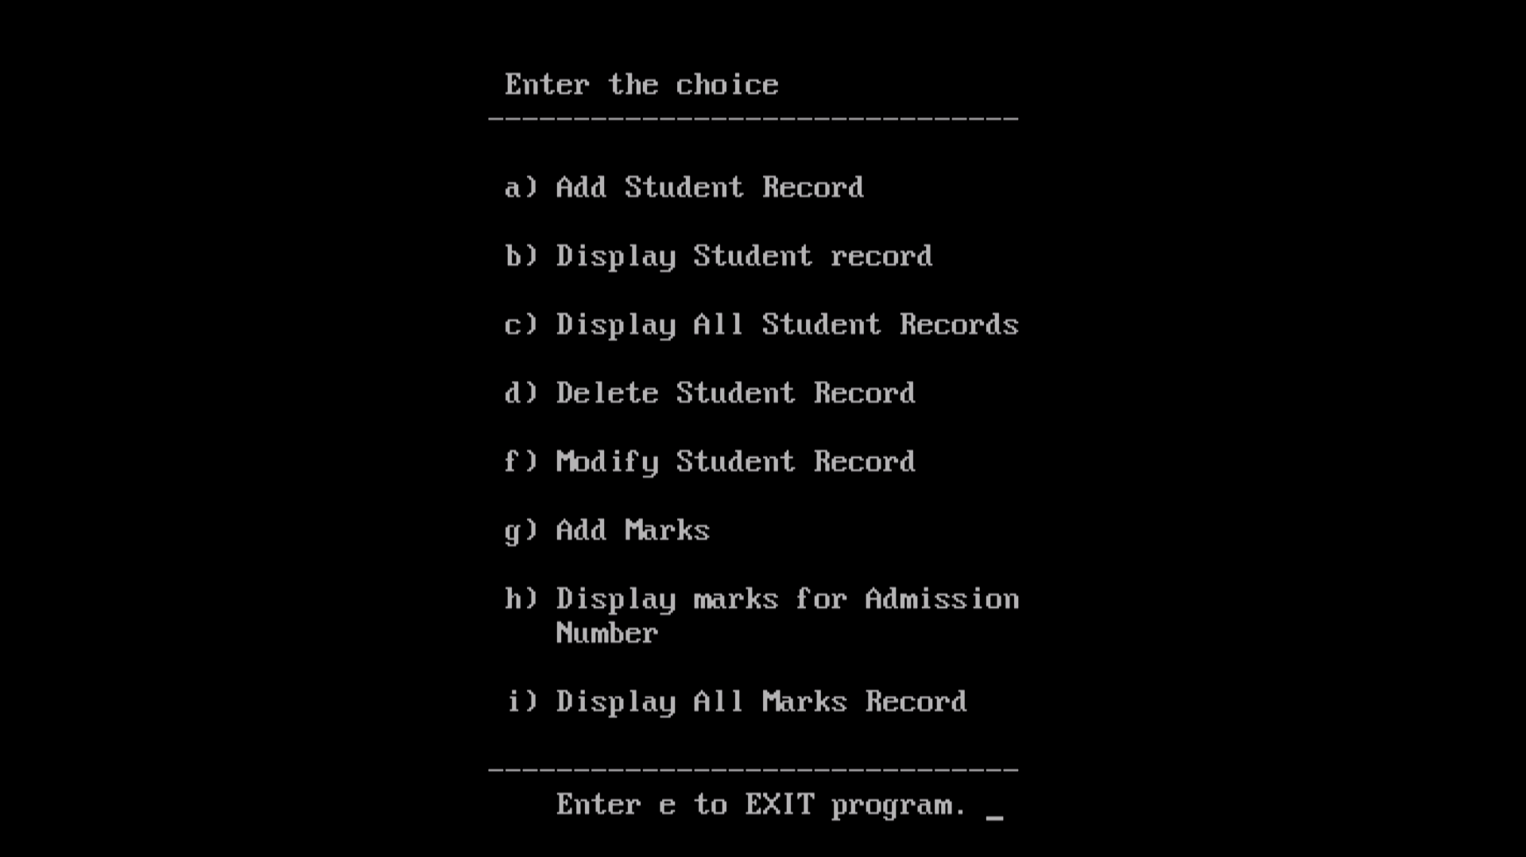

1. **New Record-to enter a new record in the file. The admission number is generated by the program so that there is no redundancy of admission number.**

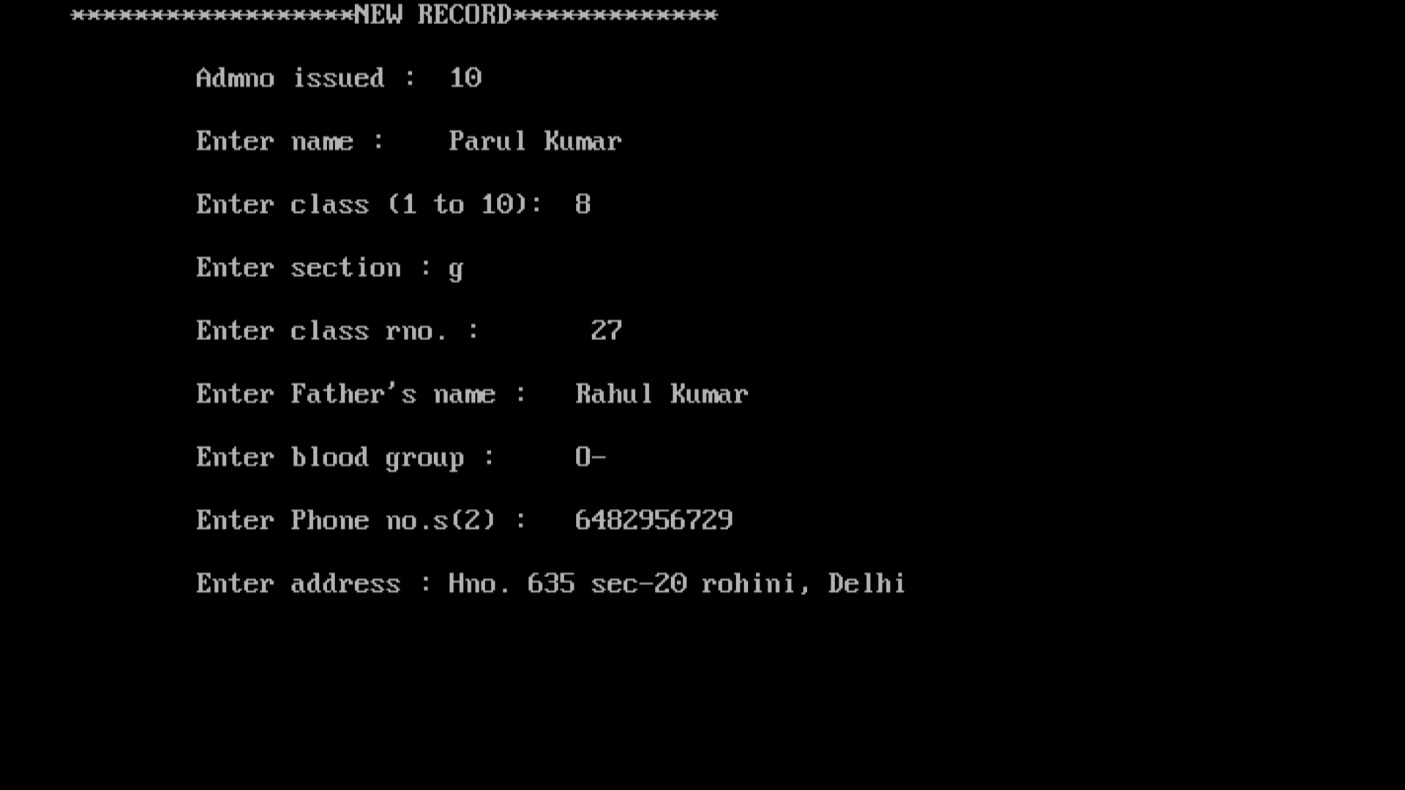

1. **A student can be searched by 2 methods.**

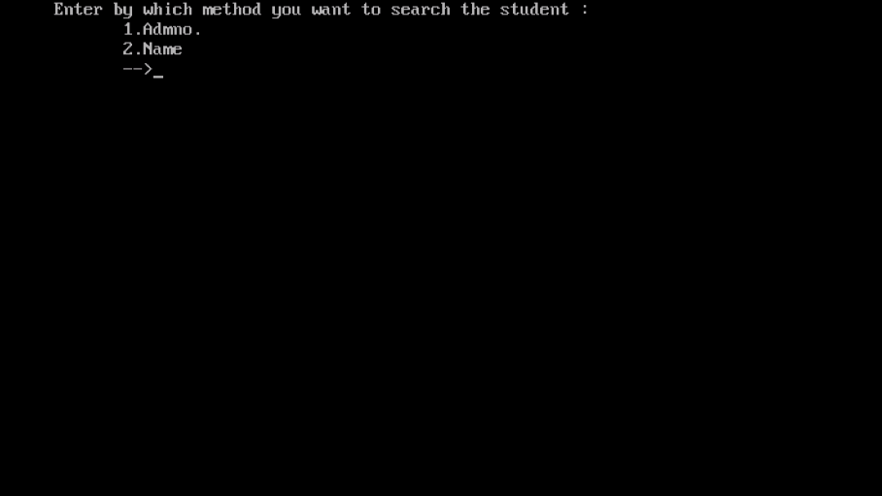

**1.By admission number** 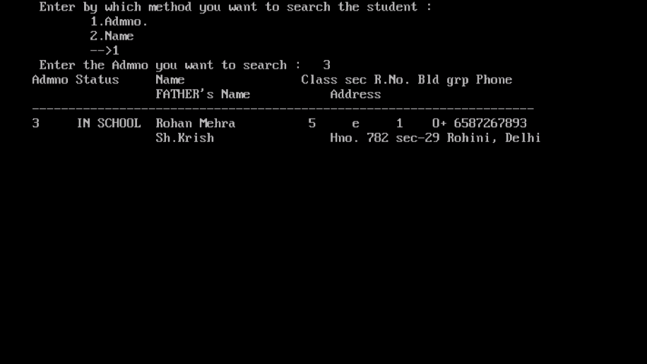

**2.By name- In this you can enter the name, it will show the number of duplicates and all the students will be displayed one by one.**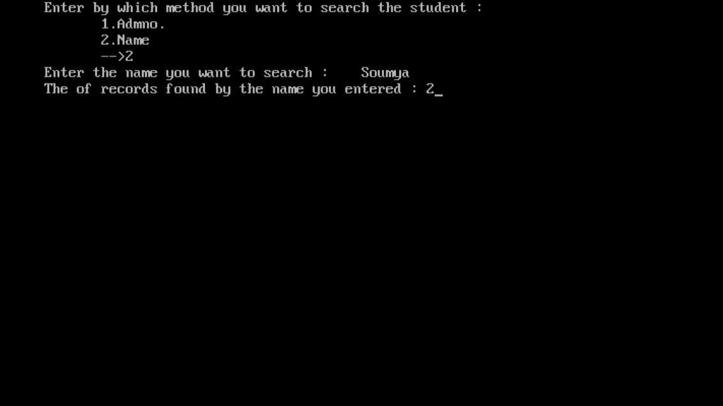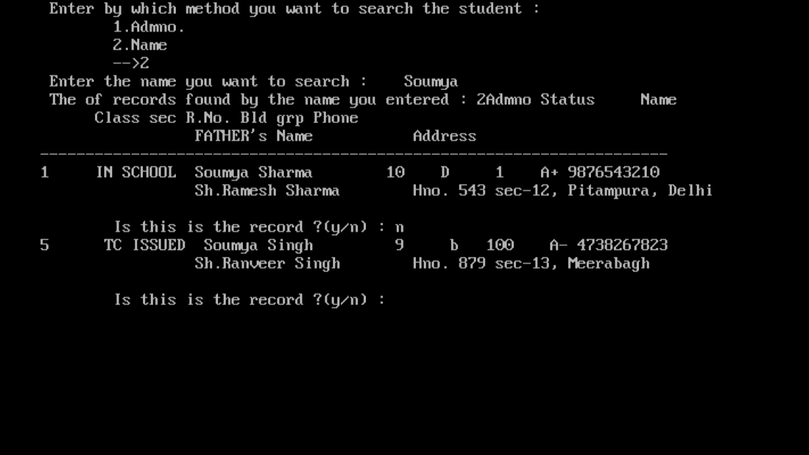

**c)Display all-it displays all records. Only 7 are displayed at once. We need t o press ‘n’ for next page and ‘e’ to exit.**

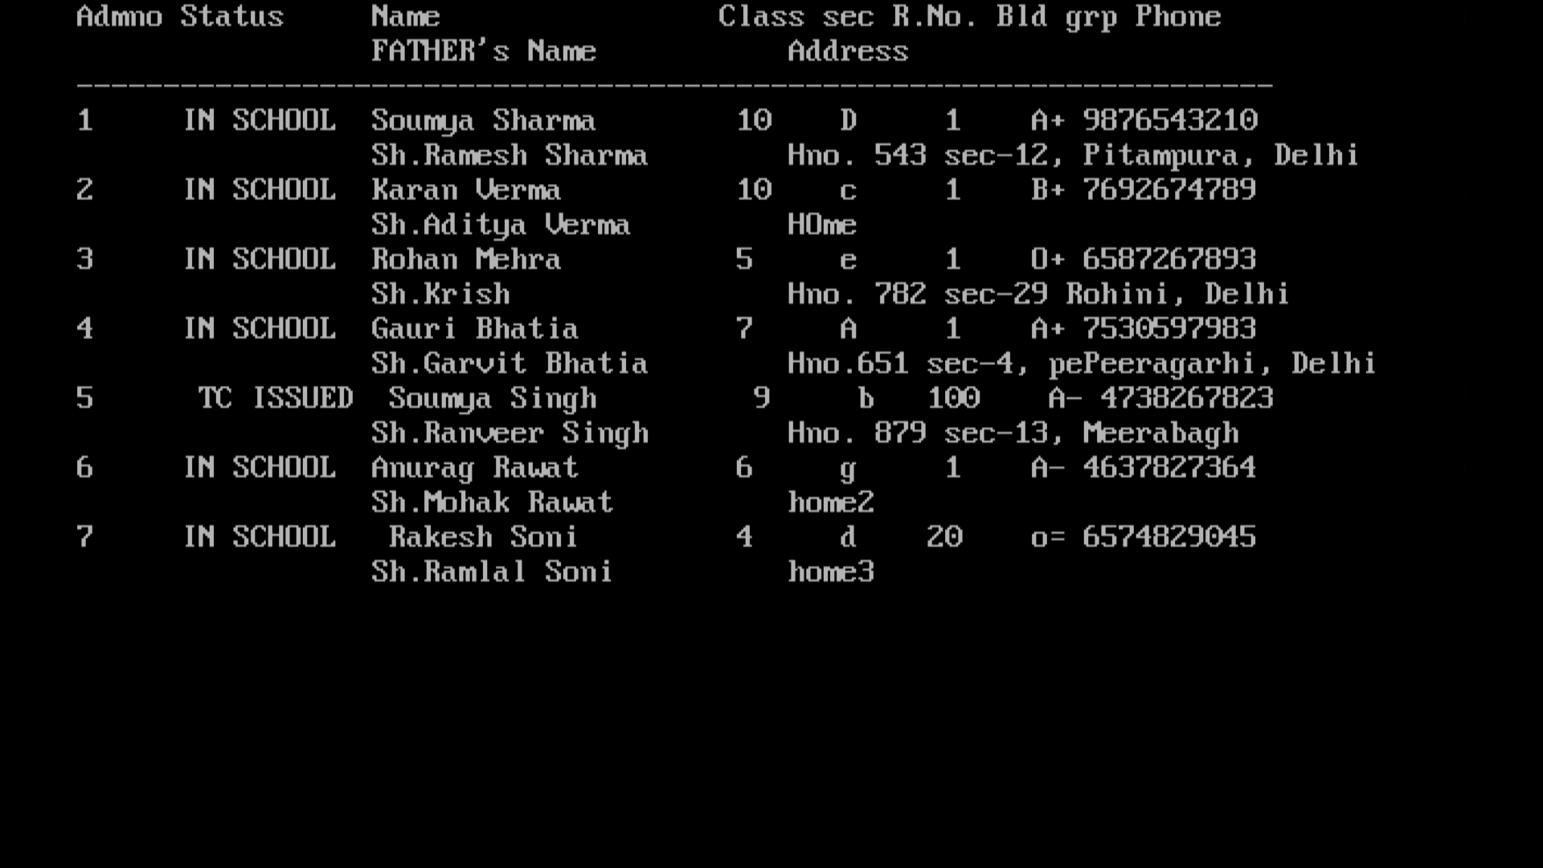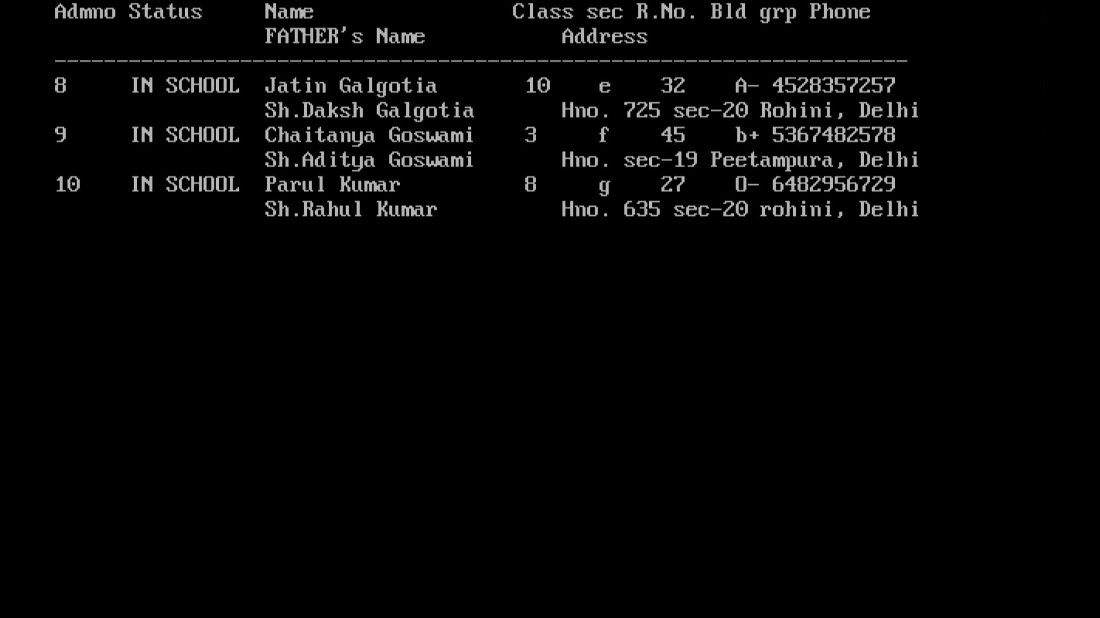

**d) Delete record- It takes admission roll no. from user. It does not really delete a students record just add either passed out or tc issued to the student as schools are required to keep the records**

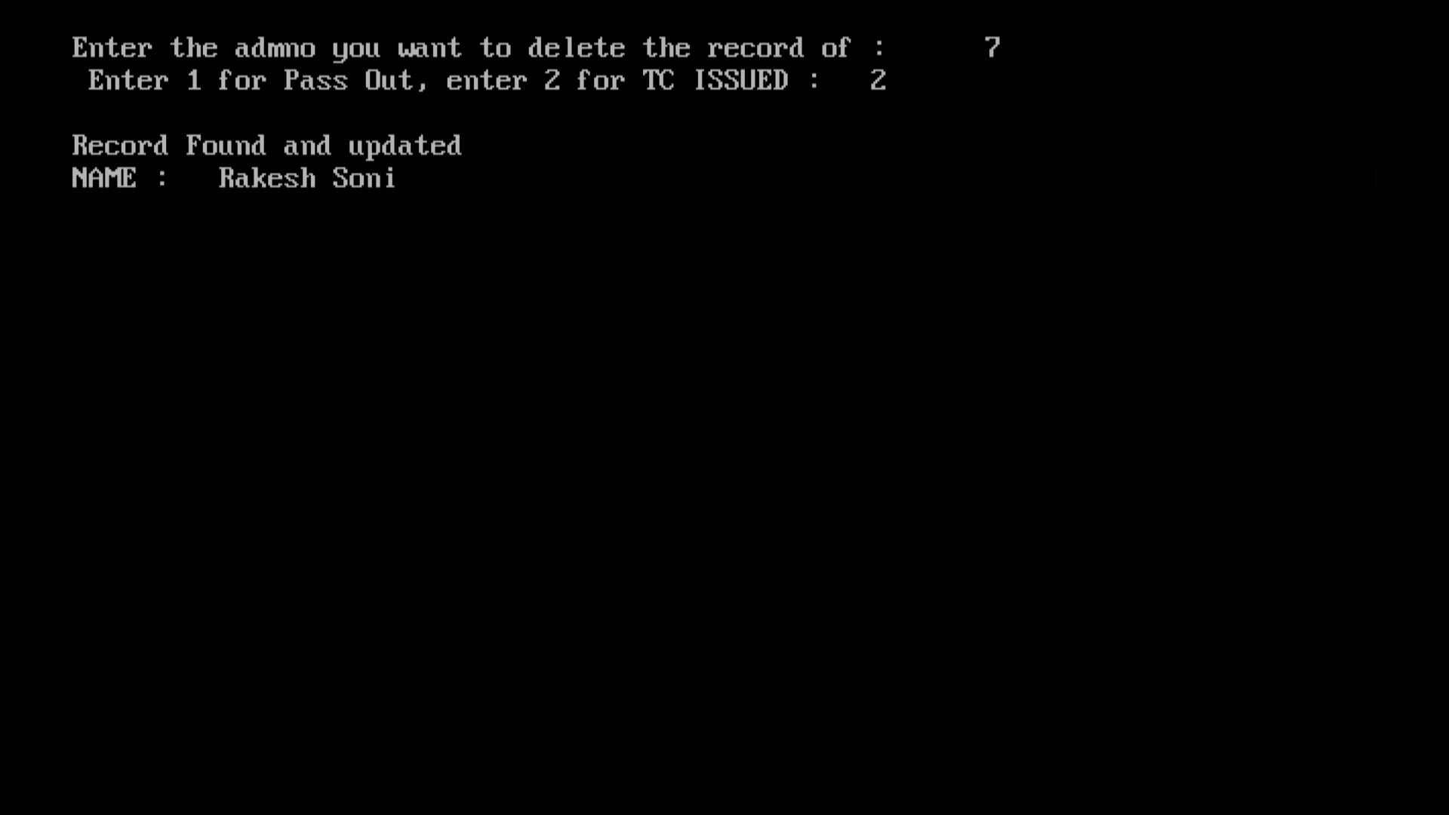

**f)Modify-It asks for the students admission no. to modify the records. The previous filled records are shown on the left and we can simply press enter to keep the same.If we want to modify we just enter the new record**

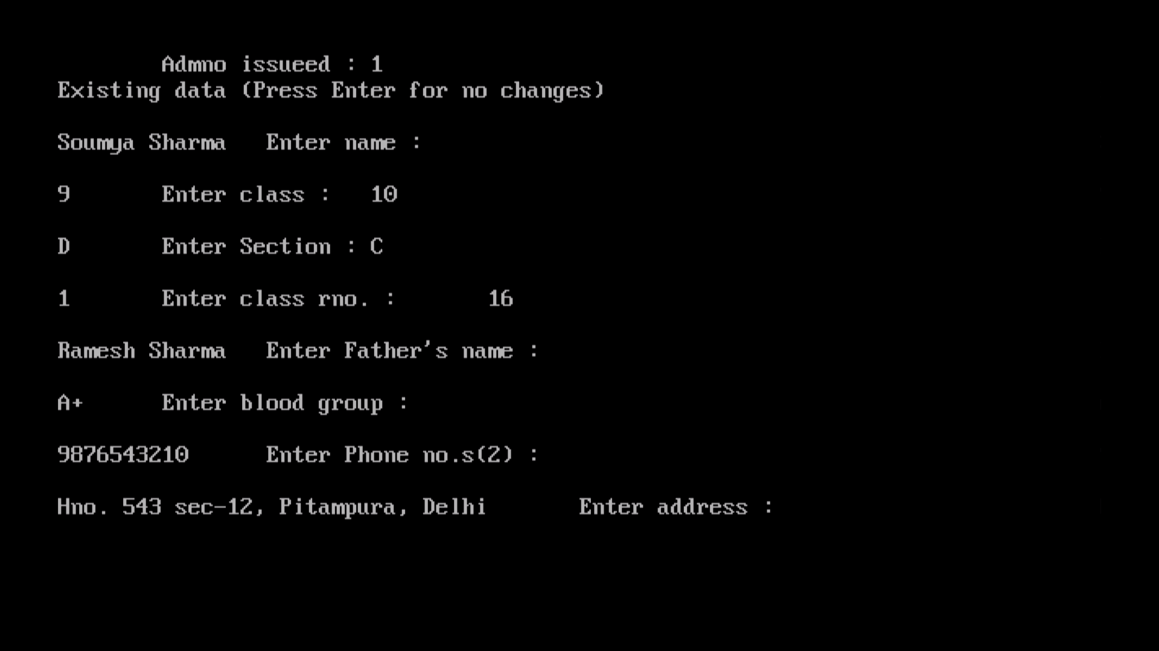

**g)Add Marks-WE can add marks of 3 terms separately**

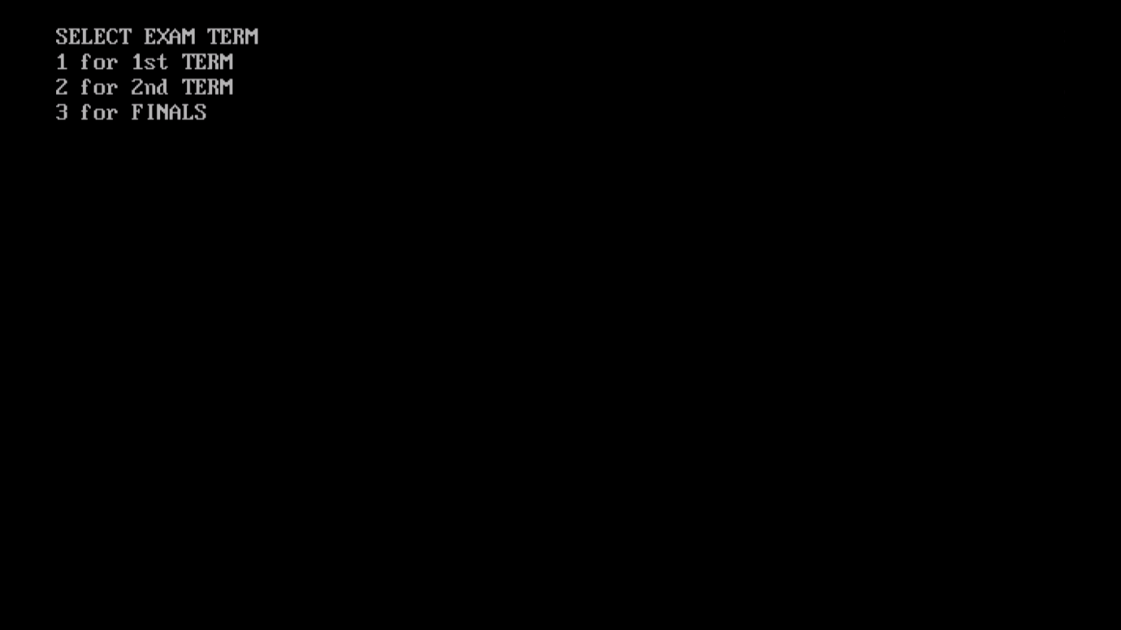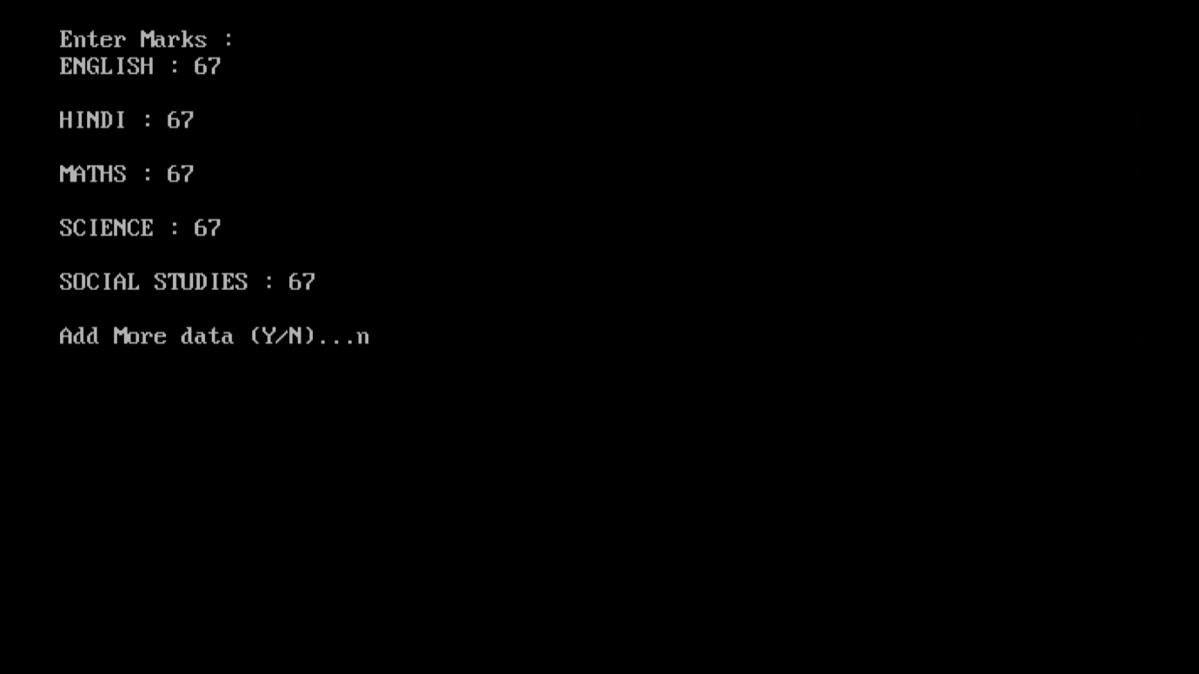

**h)Display marks- It displays marks the admission no. entered. First it confirms whether the student profile shown is correct or not.**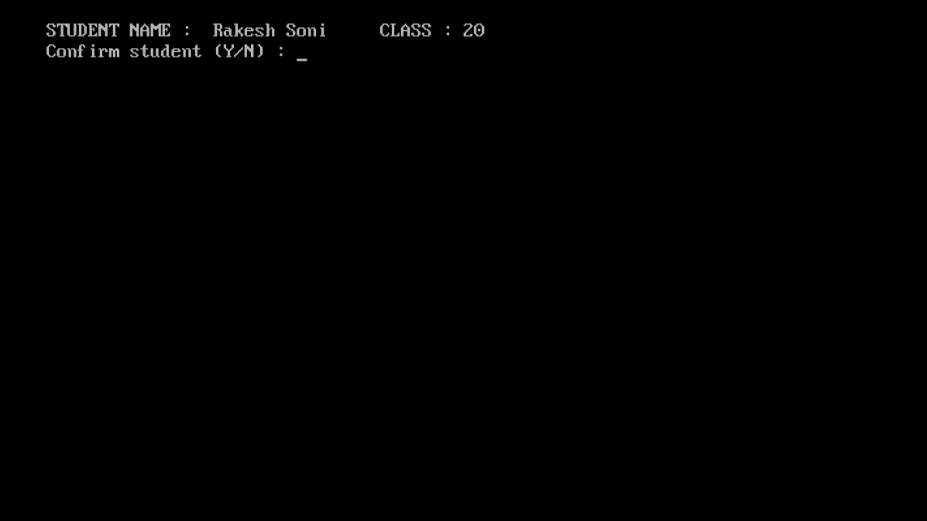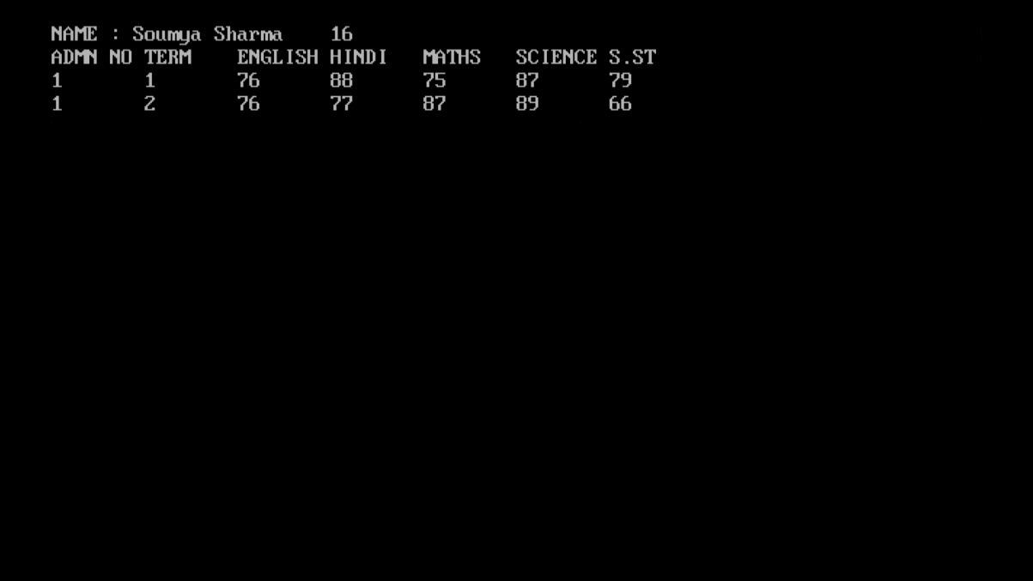

**i)Display all marks- It displays all marks of students in 3 terms with same mechanics of the first display all student records option**

**e) Pressing e instantly exits from the program .**